USHA RAMA COLLEGE OF ENGINEERING AND TECHNOLOGY
DEPARTMENT OF COMPUTER SCEINCE AND ENGINEERING
MID-I EXAMINATION Dt: 21-08-2024
Year/Sem :III B.Tech, I Sem | Programme: III B.Tech, CSE | Course Code: UR20PCCS502
Course Name: DAA | Total marks:15 | Time:90 min
CO:Course outcome Level:Bloom’s Taxonomy(Level1-6)
Answer all questions
C.no | Level | Q.No | Question
1 | 2 | 1 | Discuss in brief about Asymptotic Notations with examples?
2 | 2 | 2 | Solve Prim’s Algorithms for the given example  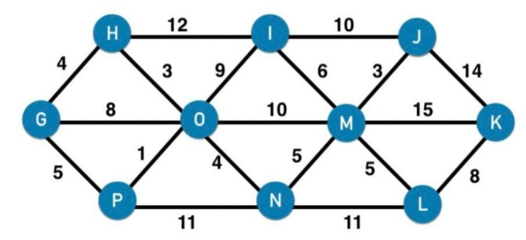
3 | 2 | 3 | Write the difference between Dynamic Programming and Greedy Method.

USHA RAMA COLLEGE OF ENGINEERING AND TECHNOLOGY
DEPARTMENT OF COMPUTER SCEINCE AND ENGINEERING
MID-I EXAMINATION Dt: 21-08-2024
Year/Sem :III B.Tech, I Sem | Programme: III B.Tech, CSE | Course Code: UR20PCCS502
Course Name: DAA | Total marks:15 | Time:90 min
CO:Course outcome Level:Bloom’s Taxonomy(Level1-6)
Answer all questions
C.no | Level | Q.No | Question
1 | 2 | 1 | Discuss in brief about Asymptotic Notations with examples?
2 | 2 | 2 | Solve Prim’s Algorithms for the given example  
3 | 2 | 3 | Write the difference between Dynamic Programming and Greedy Method.

USHA RAMA COLLEGE OF ENGINEERING AND TECHNOLOGY
DEPARTMENT OF COMPUTER SCEINCE AND ENGINEERING
MID-I EXAMINATION Dt: 21-08-2024
Year/Sem :III B.Tech, I Sem | Programme: III B.Tech, CSE | Course Code: UR20PCCS502
Course Name: DAA | Total marks:15 | Time:90 min
CO:Course outcome Level:Bloom’s Taxonomy(Level1-6)
Answer all questions
C.no | Level | Q.No | Question
1 | 2 | 1 | Discuss in brief about Asymptotic Notations with examples?
2 | 2 | 2 | Solve Prim’s Algorithms for the given example  
3 | 2 | 3 | Write the difference between Dynamic Programming and Greedy Method.

